Pages 91-92 and Page 113 ***Java Programming A Comprehensive Introduction***

**Section 1: Define / Answer**

How does a **for** loop with multiple loop control variables operate? If multiple variables used, the condition must be combination of variables that we have used in the loop. When use multiples variable it has to be separated with comma (,).

Explain the execution of the following Nested **for** loops

for (int i = 1; i < 5; i++){

* variable starts with value 1
* to break the loop variable “i’ must be 5
* each time loop goes variable increase by 1.

System.out.println("Outer Loop " + i);

* Each time loop goes through, print the value of i. the output will be
* “outer Loop” 1 then execute the nested for loop
* “outer Loop” 2 then execute the nested for loop
* “outer Loop” 3 then execute the nested for loop
* “outer Loop” 4 then execute the nested for loop

for (int j = 1; j < i; j++, j++)

System.out.println("Inner Loop " + j);

* the variable intitialize with 1, and increment by 2 each time,
* to execute the loop j must be less than i.

Explain the execution of the following Nested **while** loops

for (int a =0; a <3; a++){

System.out.println("Outer loop count: " + a);

System.out.print(" Inner loop count: ");

* the variable ‘a’ assigned to be 0
* ‘a’ is increasing by 1 each looping
* if a is 3, loop break

int t = 0;

* initialize the another variable ‘t’ with zero.
* Here, though variable ‘t’ will have some value after looping while loop, when ‘t’ comes outside it again assign to zero.

while(t<100){

* here, to execute while loop, ‘t’ must be less than 100
* To execute the ‘if’ statement ‘t’ must be equal to 10, and after execution the ‘while’ loop will break.

if(t == 10) break;

System.out.print(t + " ");

- printing out the value of ‘t’ and a space after that

t++; }

- the vaiable t is increasing by 1 each time its looping inside ‘while’ loop.

System.out.println();

- giving a space between the value of ‘t’ and outside string.

}

System.out.println("Loops complete");

This string is outside of while loop, after while loop break, it execute one time.

**Programming Assignments**

**1st Task-** Expanding the **for** loop. PG. 116 #17 in Java Programming *A Comprehensive Introduction*

Write a program that uses a **for** loop to print a list of 100 numbers consisting of alternating 1’s and -1’s, starting with 1.

Use 2 loop control variables.

Sample Output from System.out.println

i = 1 / j = -1

i = 2 / j = -2

i = 3 / j = -3

i = 4 / j = -4

i = 5 / j = -5

i = 6 / j = -6

i = 7 / j = -7

i = 8 / j = -8

i = 9 / j = -9

i = 10 / j = -10

**cont…**

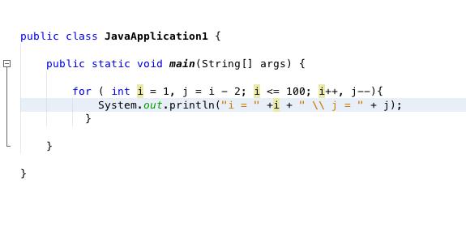

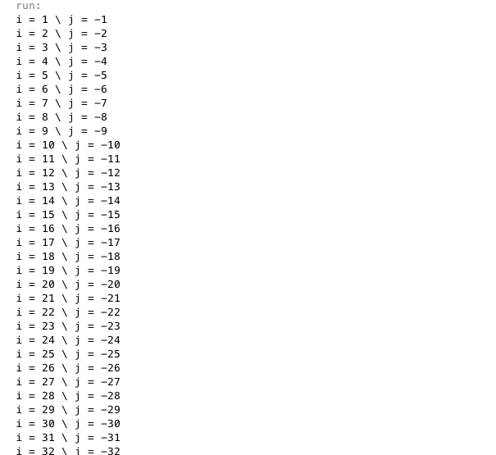

---------continue..

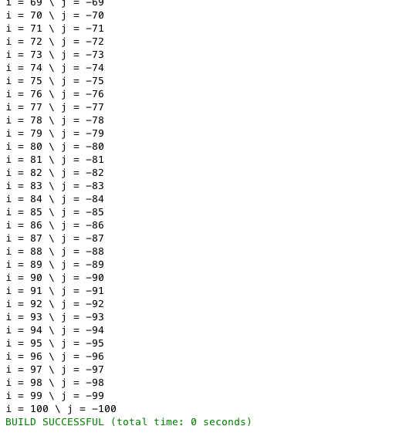

**2nd Task-**

Create a multiplication table for numbers 1 – 9,and all the multiples up to 9.

Use a Nested **for** Loop to print the table.

**Formatting is key for this assignment**, your output should exactly match the output below.

Expected Output

Multiplication Table

1 2 3 4 5 6 7 8 9

---------------------------------------------------------

1| 1 2 3 4 5 6 7 8 9

2| 2 4 6 8 10 12 14 16 18

3| 3 6 9 12 15 18 21 24 27

4| 4 8 12 16 20 24 28 32 36

5| 5 10 15 20 25 30 35 40 45

1| 6 12 18 24 30 36 42 48 54

Etc...

Page 116 #20, ***Java Programming A Comprehensive Introduction***

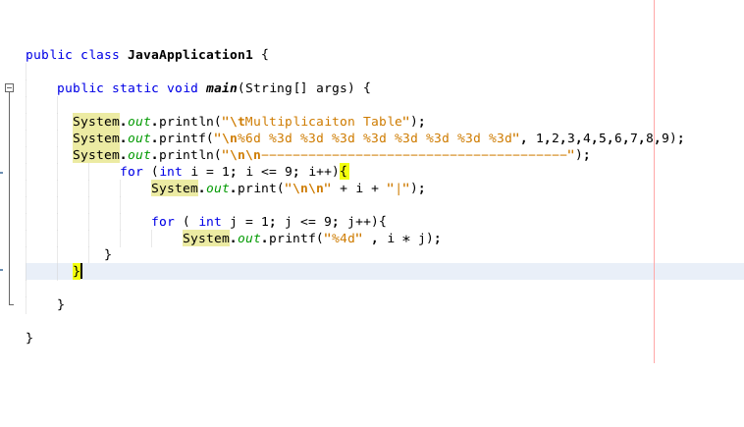

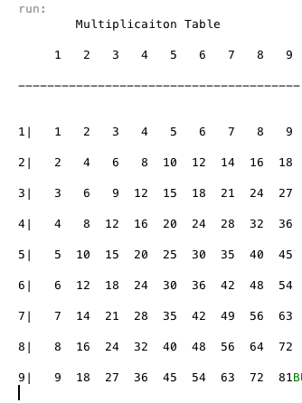

**Task 3:** Print the following combination of stars using a **for** loop nested inside a **for** loop. Then a **while** loop nested inside a **for** loop.

Each letter will have two separate programs that produce the same output.

Attach Snipping photo of the source code for all 6 exercises and output.

A.

*****

****

***

**

*

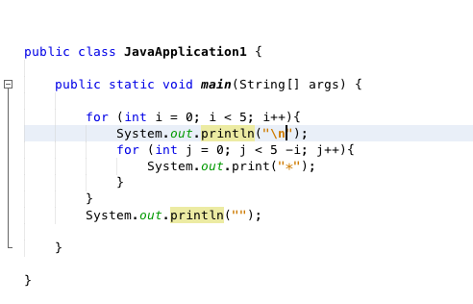

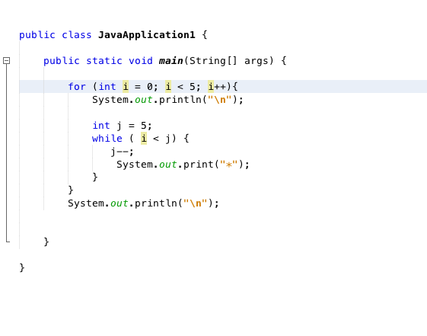

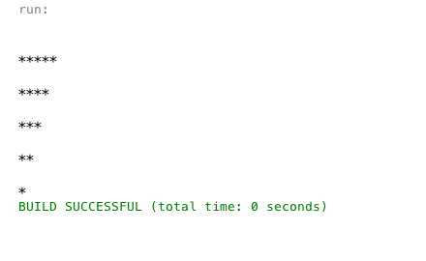

B.

*

**

***

****

*****

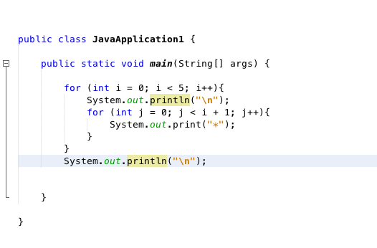

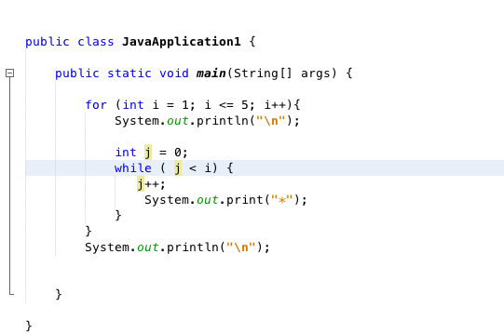

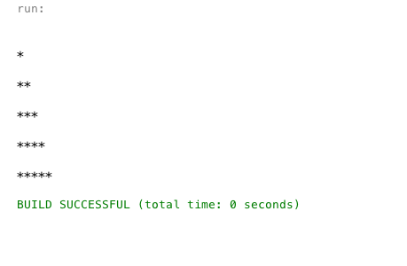

C.

**********

********

******

****

**

